VLAN
A local area network (LAN) is a collection of devices connected together in one physical location, such as a building, office, or home.
VLANs are logical grouping of devices in the same broadcast domain. VLANs are usually configured on switches by placing some interfaces into one broadcast domain and some interfaces into another . There is five types of VLAN these are Data VLAN , Default VLAN , Native VLAN , Management VLAN , Voice VLAN.
Another thing about VLAN is vlan trunking protocol,this protocol aims to manage all configured VLANs across a switch internetwork & maintain consistency and it Allows an administrator to add, delete & rename VLAN’s. There three types of vtp these are server,client and transparent.
Main advantages of VLAN
- VLAN makes managing physical devices less complex.
- Higher performance and reduced latency.
- It helps you to enhance network security.
- Users may work on sensitive information that must not be viewed by other users.
And disadvantages are
- A packet can leak from one VLAN to other.
- Threat in a single system may spread a virus through a whole logical network.
- A VLAN cannot forward network traffic to other VLANs.
Network Traffic in Network Environment Without VLAN
Let's take a look at how data transfer takes place in a vain-free network in order to understand the VLAN logic more clearly.
• We want to send a data packet from pc41 on the 3rd floor to pc9 on the 1st floor.
• Since the Destination Mac Address information of the package that came out of the PC41 was FF-FF-FF-FF-FF, it was first delivered to all computers on the 3rd floor. But the computers refused the package because the Destination Ip Address does not belong to these computers.
Network Traffic in Network Environment Without VLAN
Let's take a look at how data transfer takes place in a vain-free network in order to understand the VLAN logic more clearly.
• We want to send a data packet from pc41 on the 3rd floor to pc9 on the 1st floor.
• Since the Destination Mac Address information of the package that came out of the PC41 was FF-FF-FF-FF-FF, it was first delivered to all computers on the 3rd floor. But the computers refused the package because the Destination Ip Address does not belong to these computers.
• Likewise, this package is sent to the second floor and is delivered to all computers on the 2nd floor. The package was not received by any computer because the destination IP address did not match any of the computers on the 2nd floor.
• The package sent to the last 1st floor is delivered to all computers on the 1st floor and is rejected by all computers except pc9. pc9 is receiving the file because the IP address matches
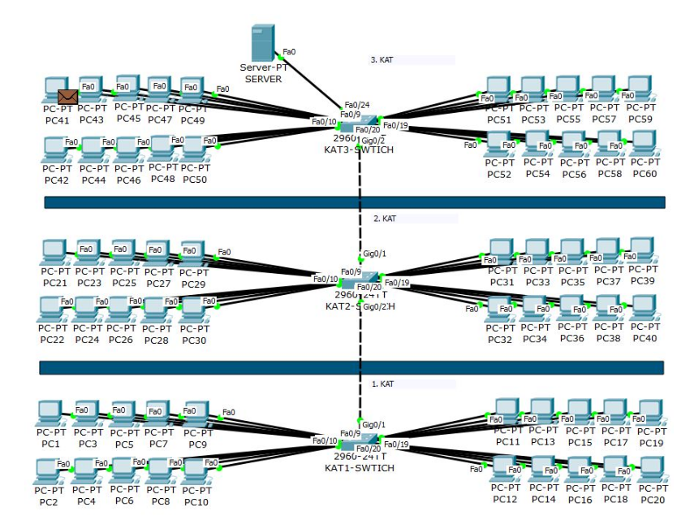

Network Traffic in Network Environment With VLAN
• We want to send a data packet from pc59 on the 3rd floor to pc20 on the 1st floor.
• Since the Destination Mac Address information of the packet is FF-FF-FF-FF-FF, the data packet coming out of pc59 will first circulate in its own VLAN network and then send the data packet to the KAT3 switch and from there to the Backbone switch to IP ROUTING to send it to the relevant VLAN.
• This data packet was directed directly to VLAN60 without ever calling KAT2.
• The package sent to all computers in VLAN60 was rejected by other computers except pc20 and received pc20 package with matching destination IP address.
